USER GUIDE TO 291 CAR RENTAL DATABASE

Welcome to our user’s guide to our database!

To create an account for this database, please hit the ‘Create Account’ Button. This will bring out a form that requires information to fill.

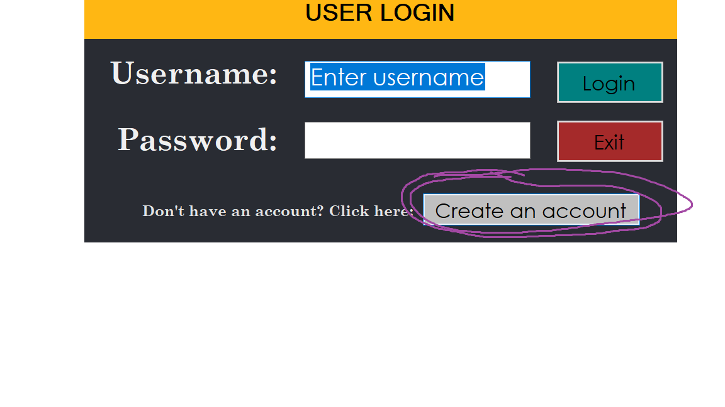

After filling up the information, click on ‘Submit’ In order to submit your submitted information. If no information required is missing, this will be successful and your account is made!

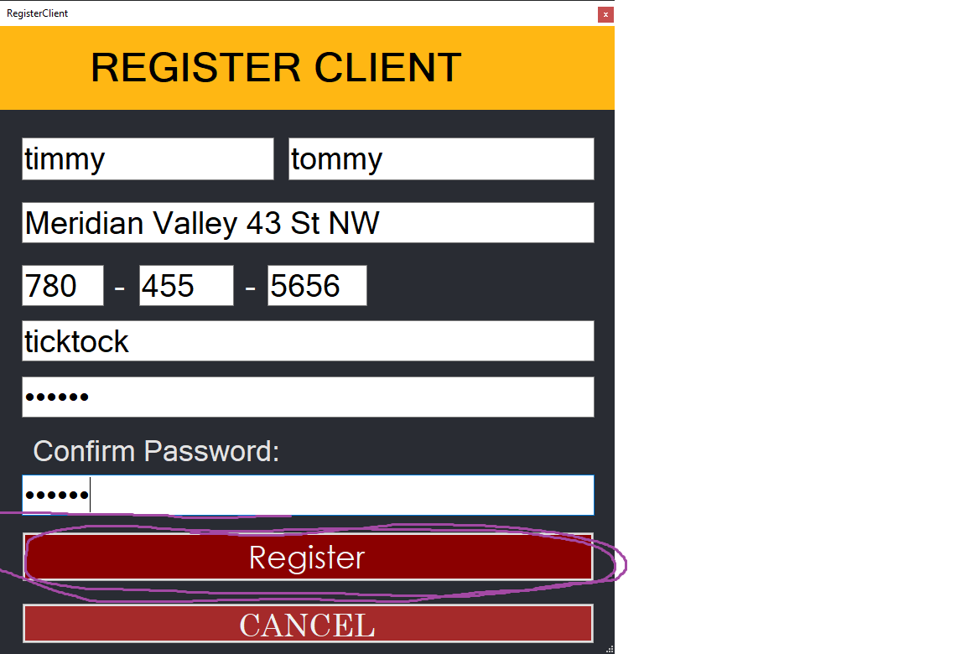

Now try logging into your freshly made account by entering in your username and password in their respective boxes, then hit the ‘Login’ Button.

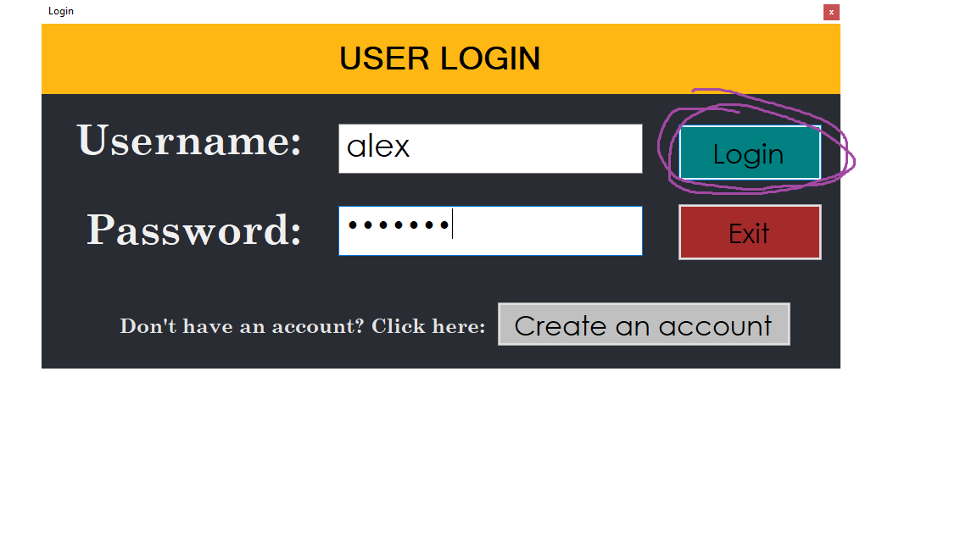

3) You are now in the landing page for our Clients! From here you have 3 options represented in three buttons:

1. ‘Rent a vehicle’ allows you to view vehicles that are available to rent!
2. ‘View Current Rental’ allows you to view any current rentals/reservations you have going on at present
3. ‘View Profile’ allows you to view your profile, and make any changes within the settings tab!

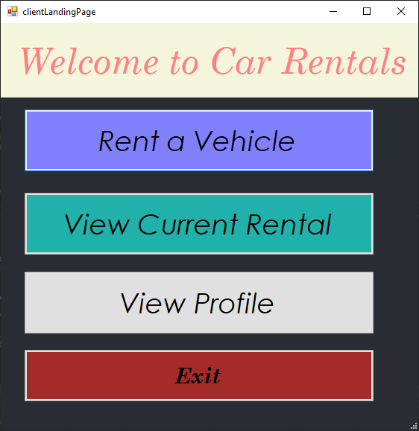

Once you are done, you can hit the ‘Exit’ button to exit out of our database program, and be on your way!